**Lab: Route 53 with S3**

**Services Used: Route53 & S3**

As this exercise requires S3 integration with Route 53, ensure domain is already registered in Route53 and ready for use.

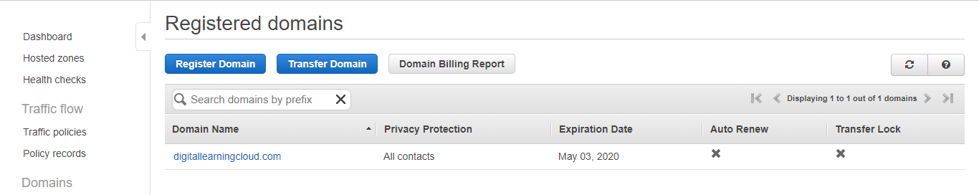

1. Go to S3 Service in AWS Console

2. Create a new S3 Bucket same name as the domain name you are configuring.

In this example [www.digitallearningcloud.com](http://www.digitallearningcloud.com) is the bucket name and already this domain is registered and available in Route53.

Configure the bucket for static website hosting [Refer the document S3 Static website hosting] and check it is working fine.

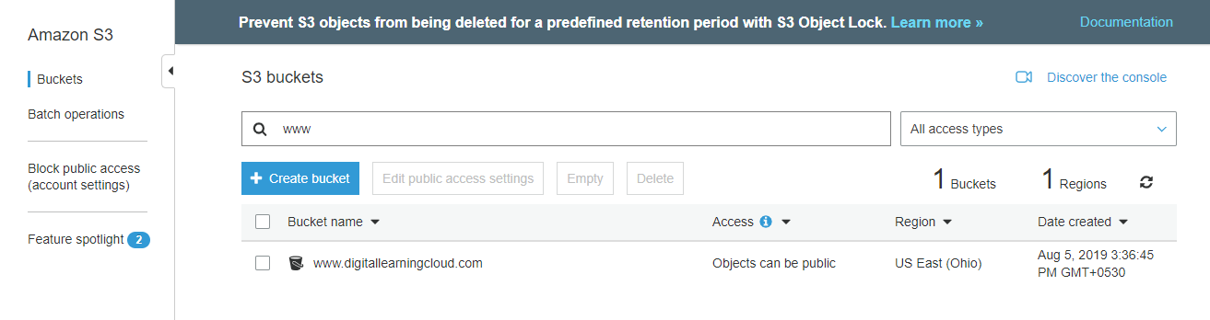

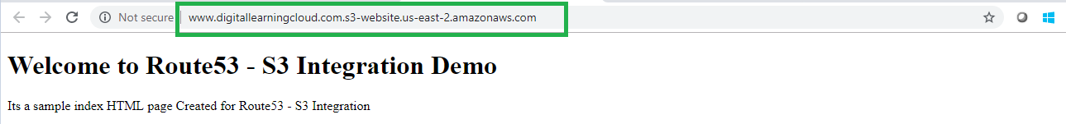

1. As S3 static website configured and ready for use, we can now make route 53 changes to point the domain address resolving to S3.
2. Click on the registered domain’s hosted zone.

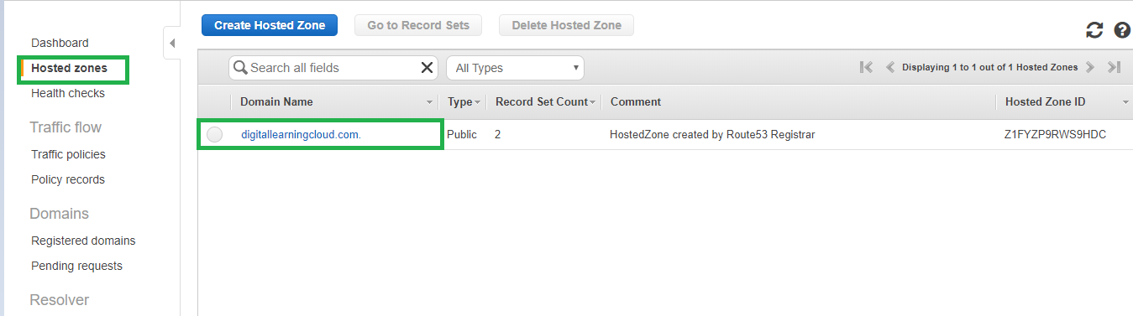

1. Click New record set to add route 53 alias record for s3 bucket.

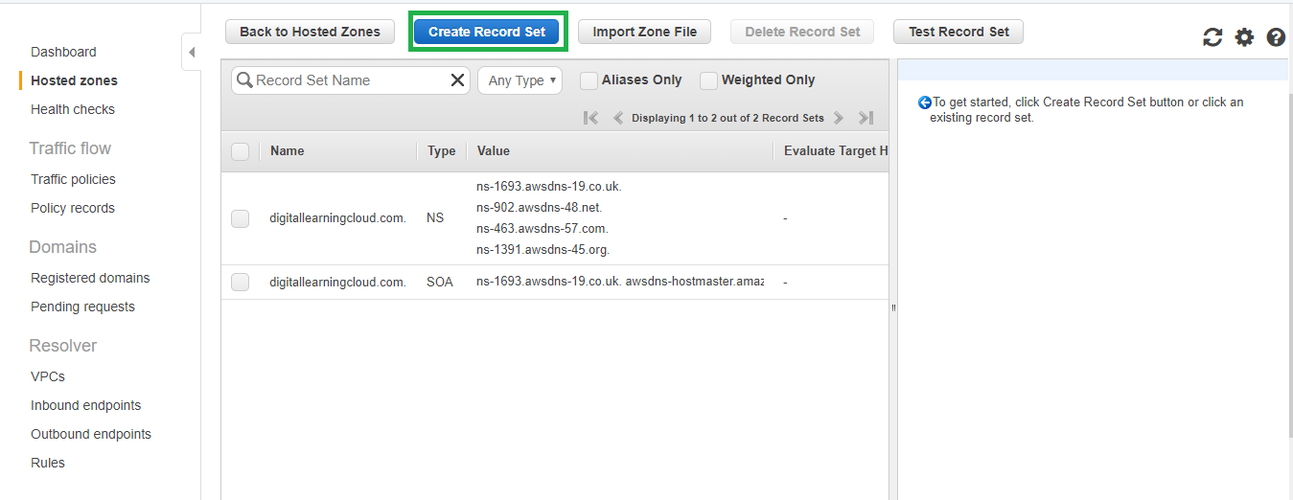

1. Provide the name as www and select alias as we are using an aws resource (S3). If your bucket naming is correctly configured as your domain you can see the S3 website endpoint being shown as below. Keep the routing policy as simple and click create.

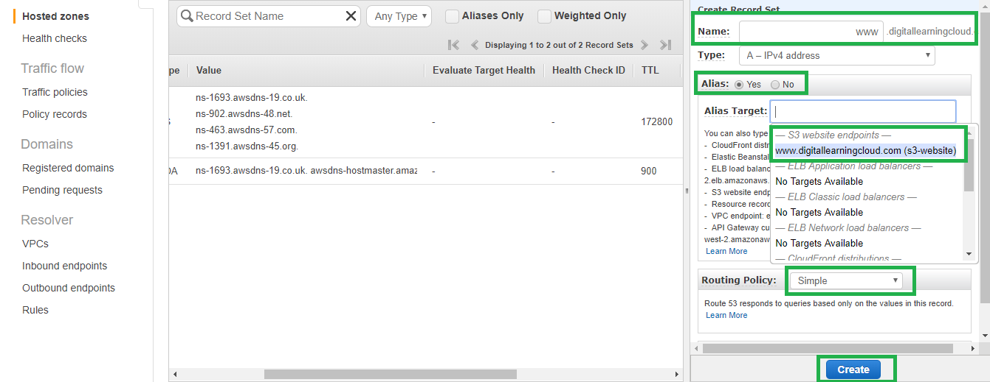

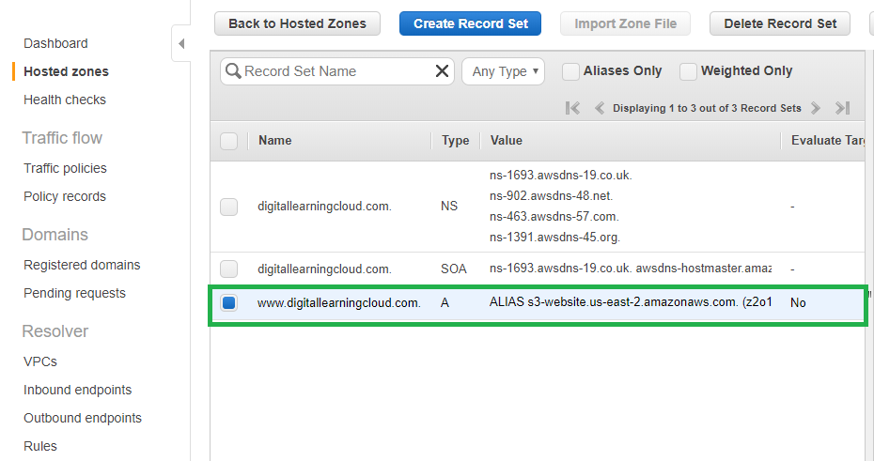

1. Try to access the site [www.digitallearningcloud.com](http://www.digitallearningcloud.com) now and see the Content of S3 being shown.

